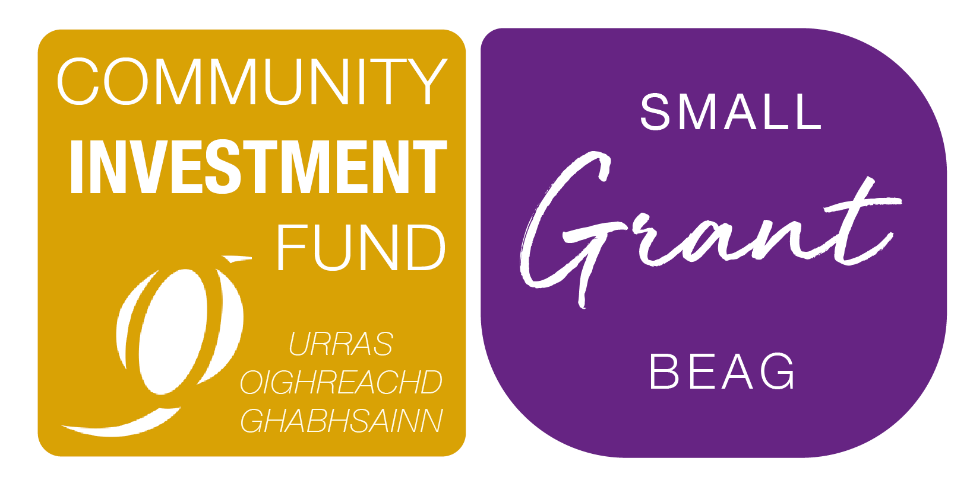


This form should only be used if you are applying for the Small Grant/Grant Beaga which is typically around £2,000. Please read the associated guidance notes before completing this form and it is recommended to contact the UOG Community Investment Officer to discuss your project before applying. If you are applying for more than £2,000 then you may need to complete an application form for the Development Grant/Grant Leasachaidh.

Part 1 – Your organisation
- What is your organisation’s name and contact details?
(Please ensure this is the full legal name as it appears on your governing document)
Organisation Name:
Address:
Postcode:
Tel:
Email:
Website:
- What type of organisation are you?
(Community organisation, youth club, social enterprise etc.)
- Do you have a constitution or set of rules setting out your aims and objectives?
- When did you organisation start? DAY / MONTH / YEAR:
- How many people are on your organisation’s management committee or board?
- Are there any restrictions on who can join your organisation?
If YES, what are they and why do you have them?

- Does your organisation have a bank or building society account with at least two signatories? Please attach a recent bank statement for the organisation
Organisation Name:
Organisation Name: | Is this the same as on your governing document? YES / NO
Bank Name: |  |  | Account Number:
Bank Address: |  |  | Sort Code:

Part 2 – Your Project

- Tell us about your project or what you intend to use the grant for (you may wish to use the below to aid completion)
What is your project name:
Outline of project (What is the project and some detail and background of the project)
List the outcomes you expect to see from carrying out this project (at least three outcomes) – explain more
If applicable tell us if your project will attract new users/customers and how it will attract them?
If your project is part of a wider improvement/ongoing development project, tell us about this?
Who within your organisation will oversee the project and take it forward to completion?
If you wish to add more information to support your application, please continue here:

- When will your project take place?
Please note your project must commence within 3 months of the start date and should be completed within 12 months.
Insert start date:
Insert end date:
10. Where are the people who will benefit from your project based?
Please note the people must be based in the Galson Estate area. Please specify if from particular townships or from the whole estate.
11. Where will your project take place?
Please enter the actual address or details the various locations it will cover.
12. How much will your project cost?
(You should include all costs, even if you are not requested funding from UOG to fund it. Please make sure costs are accurate and based on quotations where possible. DO NOT include any VAT you can claim back from HMRC.)
Item or Activity | £
TOTAL £
Amount requested from UOG £
13. If you are not requesting 100% funding from UOG, where is the remainder of your funding coming from? (please note that UOG will only offer 100% funding in exceptional circumstances)

Please confirm that you have completed everything we have asked.
Use the checklist below:
 Please tick:
I have answered all the questions in this application
I am the main contact for the organisation and am authorised to apply on behalf of the organisation
I confirm that the organisation is eligible to apply, as set out in the fund guidance
I have signed and dated the application form
I have attached costings/quotations for the project
I have attached a recent bank statement (within last 3 months)
I am able to confirm that the organisation can comply with the terms and conditions of the funding, as laid out in the terms and conditions document

Chairperson/Director |  | Main Contact
Name: |  | Name:
Position: |  | Position:
Tel: |  | Tel:
Email: |  | Email:
Signed: |  | Signed:
Date: |  | Date:

We are committed to improving our customer service and want to ensure we offer an efficient service. Would you be willing to take part in feedback and research that helps us to improve how we operate?
YES / NO

Please send your completed application to: cif@uogltd.com

Or you can post your application to:
Urras Oighreachd Ghabhsainn, UOG Business Centre,
Tom na Ba, South Galson, Isle of Lewis, HS2 0SH

