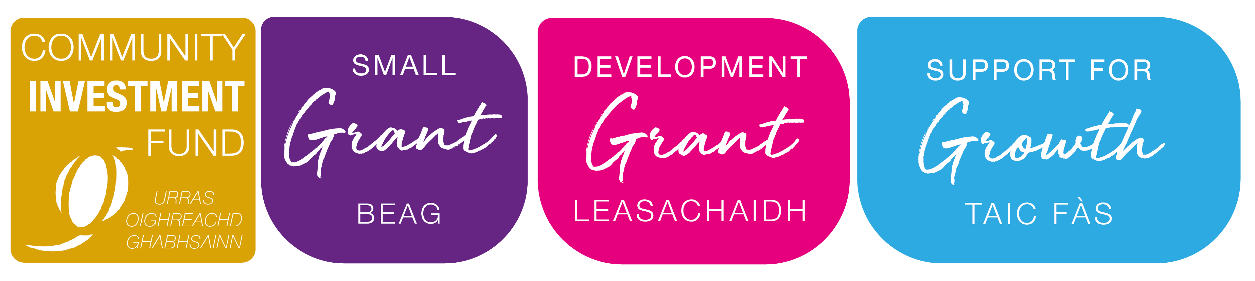


COMMUNITY INVESTMENT FUND
TERMS AND CONDITIONS OF GRANT
If you accept a grant from Urras Oighreachd Ghabhsainn it will be on the understanding that you have agreed the following general terms and conditions, which will apply for a period of 5 years from the date of the final release of grant, unless otherwise stated:
- Payment of grant is conditional on confirmation that all the funding for the project has been secured, and that our funding is sufficient to meet the actual costs of the project.
- No changes to the project will be made without our agreement. You must also inform us immediately of any proposed change relating to grant expenditure or the organisation. You must also inform us of any changes to the project even if you have not yet drawn down any grant.
- You must provide information to enable us to prepare a project completion form, this will take place at the end of your project as indicated on your application.
- You should keep accurate and comprehensive financial records of the spending for the project and provide these when the project completion form is being prepared at the end of the project. The grant should also be specifically acknowledged within your annual accounts for the year in which it was received.
- We will provide you with a plaque, sign, sticker or equivalent promotional material which should be displayed in a prominent and appropriate position on property, plant, installations or equipment directly affected by your project. Reasonable costs for fixing promotional material can be included in the project costs. In addition, the grant should be acknowledged in all printed materials that you produce about the work for which you have received funding, and acknowledged appropriately elsewhere, for example in annual reports or brochures. If you want to make use of our logo we can provide it on request.
- We will use your name in our publicity material, along with images and some project information such as available through case studies. You consent to the use of this information which will be used purely for promotional purposes in accordance with any reasonable requests that you may make, for example, to protect confidential or sensitive details.
- You should expect that we will visit to see the work that is being funded during the life of the grant.
- Any part of the grant that is not required for the purpose approved must be refunded to us.
- We reserve the right to withhold a grant or require repayment if: we find that any false information is supplied deliberately; the work undertaken is not the work for which the grant was approved (and if we have not been informed of and approved these changes); your organisation becomes insolvent or goes into administration, receivership or liquidation, and if the grant has not already been spent on its intended purpose.
- Where the grant is used for the purchase, erection, installation or improvement of property, equipment, machinery, plant or similar assets, these may not be sold within five years without our prior written consent. Within this period, we will be entitled to the proceeds of the disposal, or the relevant proportion of the proceeds based on the percentage of grant funding used in connection with the acquisition or improvement of the asset against the whole proceeds. We will also be entitled to the relevant proportion of any proceeds resulting from any provision included as a condition of sale.
- Any property, equipment, plant, installations or similar assets acquired or improved through the project must be maintained in a good state of repair and included in a relevant insurance policy where that is commercially available at reasonable rates.
- We expect you to operate with good management practice and a commitment to Equal Opportunities principles and practices in relation to your workers, volunteers and users.
- We strive to be a low carbon community and we expect you to operate in this manner also.
- We reserve the right to share the information you have provided with relevant parties (e.g. OSCR) where appropriate. This will be in accordance with our Privacy Policy, a copy of which can be provided on request.
We will sometimes add additional conditions to an individual grant to take account of particular circumstances. These will be included in the grant offer letter.

You will need to sign one copy of these terms and conditions and return it to us; this will act as confirmation that the money will be spent on the purpose approved.

Grant Ref:
Organisation:
Name:
Position:
Signed:
Date:

Please retain one copy for your records and return one signed copy to:

Urras Oighreachd Ghabhsainn
UOG Business Centre, Tom na Ba, South Galson, Isle of Lewis HS2 0SH
Email: cif@uogltd.com Tel: 01851 850411

